KING’S OWN INSTITUTE*

**Success in Higher Education**

**GROUP ASSIGNMENT COVERSHEET**

Subject Code & Name: Lecturer’s/Tutor’s name:

ICT203 Human Computer Interaction

Andres Pinilla

Assignment Title:

Website prototype design report

Declaration

(This declaration must be completed by all students in the group or the assignment will not be marked.)

We, the undersigned, certify the following:

* We have read and understood the *Student Academic Misconduct Policy*
* This assignment is our own work based on our personal study and or research.
* We have acknowledged all material and sources used in the preparation of this assignment including any material generated in the course of our employment.
* **The assignment has not previously been submitted for assessment in this or any other unit.**
* We have not copied in part or in whole or otherwise plagiarised the work of other students.
* We have read and understand the criteria used for assessment.
* The assignment is within the word and page limits specified in the unit outline.
* The use of any material in this assignment does not infringe the intellectual property / copyright of a third party.
* We understand that this assignment may undergo electronic detection for plagiarism, and an anonymous copy of the assignment may be retained on the database and used to make comparisons with other assignments in future.
* By completing this coversheet in full and submitting this assignment electronically, we are bound by the conditions of the KOI's *Student Academic Misconduct Policy* and the declaration on this coversheet.

|  |  |  |  |  |  |  |
| --- | --- | --- | --- | --- | --- | --- |
|  | Family Name | Given Name(s) | Student ID | Tutorial Code | Contribution Percentage | Signature |
| Student 1 | Regmi | Bimal | 12100195 | LBT1 | 100 | Bimal |
| Student 2 | Bhetuwal | Amit | 12100668 | LBT1 | 100 | Amit |
| Student 3 | Kandel | Sujan | 12200901 | LBT1 | 100 | Sujan |
| Student 4 | Khadka | Bhoj Bahadur | 12100199 | LBT1 | 100 | Bhoj |
| Student 5 |  |  |  |  |  |  |

Assignment Receipt

Subject Code & Name: ICT203 Human Computer Interaction

Lecturer’s/Tutor’s Name: Andres Pinilla

Assignment Title:

Website prototype design report

|  |  |  |  |  |  |
| --- | --- | --- | --- | --- | --- |
|  | Family Name | Given Name(s) | Student ID | Tutorial/ Code | Signature |
| Student 1 | Regmi | Bimal | 12100195 | LBT1 | Bimal |
| Student 2 | Bhetuwal | Amit | 12100668 | LBT1 | Amit |
| Student 3 | Kandel | Sujan | 12200901 | LBT1 | Sujan |
| Student 4 | Khadka | Bhoj Bahadur | 12100199 | LBT1 | Bhoj |
| Student 5 |  |  |  |  |  |

GROUP ASSIGNMENT COVER SHEET * AUSTRALIAN INSTITUTE OF BUSINESS AND MANAGEMENT PTY LTD PAGE **1** OF **1**

16 January 2023 CRICOS 03171A ABN: 72 132 629 979

Table of Contents

1. Introduction 4

2. Design of Student burger house website: 4

2.1 Homepage: 5

2.2 Menu page: 6

2.3 Gallery page: 6

2.4 Our services: 6

2.5 About and Contact Page 6

2.6 The order page: 6

2.7 Prototype development: 7

2.8 Screenshots: 8

3. Test Cases: 11

4. Testing and Evaluation 11

4.1 People to test the website: 12

4.2 Questions for Testing and Evaluation: 12

5.3 Feedback Graph 13

5. Conclusion: 13

6. Recommendation: 14

7. Member Participation: 14

8. Link to the websites’ HTML and CSS: 14

9. References: 15

10. Annex 15

# Introduction

There are very few things that we can do without the help of the internet these days, from cooking food to driving a car, the internet has been used in every aspect of the modern world. The Internet has made a lot of work easier, faster, and more efficient. There are millions of websites in today’s world, pretty much for everything. From small restaurants, and retail shops to giant companies they all have websites. These businesses have used websites to communicate with their customers, keep them informed about the various offers, and discounts, and sell their goods or services as well. We are building a website for a restaurant called Student Burger House based in Sydney. Student Burger House is a restaurant where we get a variety of Burgers with other fast food in one place, so it is named after it. This restaurant is one of the most famous in the city because of the variety of burgers and it is run by a group of students studying for bachelors in one of the top universities in Australia.

Our restaurant is also taking orders online with the help of the website. Our website not only takes orders but also shows the menu, and customers can add comments and give suggestions to improve the quality of the restaurant.

# Design of Student burger house website:

This was the basic wireframe that we had in mind, at the very beginning of the design:

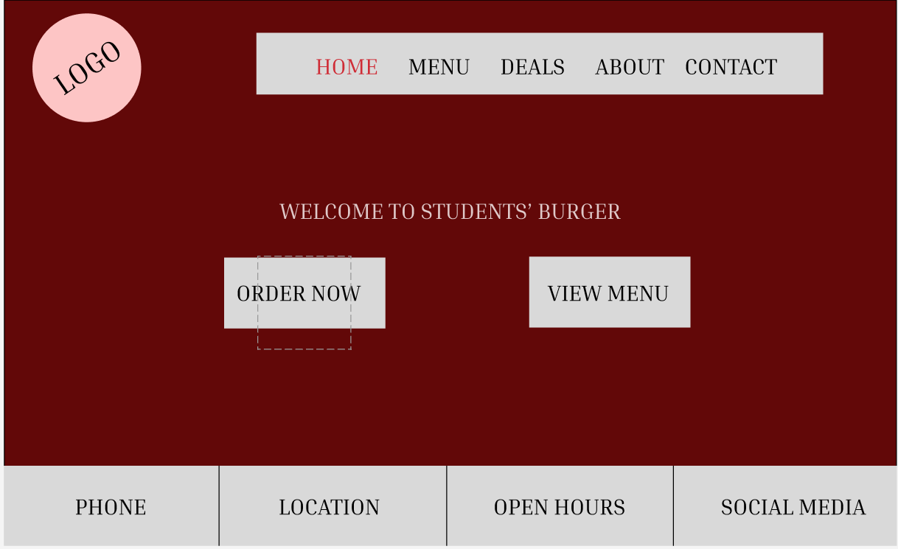

Figure: homepage of Students Burger House restaurant

The main aim of the website we’re trying to build will be to help Student burger house in different aspects while running the business. The focus will be on creating a website that is very user/customer friendly and can also help the business save some manpower expenses as well. For a business, especially a burger shop to run properly, website, contents on the website, need to be very user-friendly.

While we were building this website; several steps were taken care of and were considered. Few of the rules that were taken into consideration while building this website are presented below.

**User control:**

The satisfaction of the user is the most important while building any UI. The UI should be able to let the user control various things, it must be flexible, facilitative, and informative, and should be able to run flawlessly no matter what device the user is using.

**Consistent interface:**

One of the red signs of any website or UI is inconsistent and with errors. For users to have an amazing experience the UI should be error-free. The interaction result and experience should be the same every time user is using the interface. The UI should be so engaging that users want to be on the website for a longer time and want to keep looking for goods/products.

**Informative feedback:**

Keeping users aware of what has been done in the website. And asking users to give their feedback and opinion on how the user experience was for them. And in their opinion, what could have been done in order to make it more user friendly and reliable has been asked in our bottom part of the website.

**Respective design:**

Design on our website, is extremely consistent and we have used the same color background in the whole of the website so the user feels more user friendly. The website also responds on the basis of when the webpage is resized or assessed through different devices.

**Alignment:**

All of the components in this website are aligned properly. Doing so has caused, the website to look in order and has made sure that the user will not feel like something has been placed randomly. These alignments can be seen throughout the website, from the navigation bar to the whole of the website.

**Hierarchy:**

Hierarchy means placing the most important thing at first and in the same order. This is done so that the user can find the most important thing or the thing he is looking for quickly. It is the homepage of our website, the navigation bar is at the top, which is followed by our restaurants’ short information and the option to order food.

**Contrast:**

We have used light green purple and various order colour which have a good contrast with each other. This has made our website look sharper and more appealing to the users’ eye. And the important information like the order option and the food options also has a hover feature making the contrast more efficient.

**Proximity:**

Proximity means if a user looks at the website he can see how the parts and components of the design have been put together so that the user will not feel anything missing or anything irrelevant to another part in the webpage. Each and part is connected to one another so that the user can always feel a sense of good interaction and almost feel like turning a page.

## 2.1 Homepage:

The home page is the main page of any website that is built. The homepage will be the 1st page where the user will be on the website. The design of the homepage needs to be done with efficiency. The homepage must be very user-friendly, easy to interact with, and easy to go with different options. A proper heading (mostly the name of the business) is a must while creating an appropriate heading. The homepage will also need to have a short description of the business and what they are offering.

There can be multiple subheadings on the homepage, they will provide a bit of detailed information about the business. In our case, the subheading can include what service/foods are the customer looking for. That will make customers engaged and interact on the homepage.

The homage needs to have a few high-quality pictures of the products or the staff working there, or it could be any information about the business. We can add more information on the homepage about different ways for customers to interact with the business. We can include different social media links on the homepage, including an AI chat system or the direct phone number of the business.

## 2.2 Menu page:

This will be another important page for the profitability of the business. The items on the page will be categorized into various sections. They can be various categories here such as burgers, fries, drinks, or other goods that the business offers. This is the selection where customers can click on their desired menu and go a little further on what their desired goods are. That will redirect the customer to a different page where there will be pictures of the specific menu customer is looking for as well. We can have a section under the category burger like a chicken burger, beef burger, veggie burger, and so on. We can have another section there as well which will mention a signature menu for a certain day.

## 2.3 Gallery page:

All of the photographs collected on this page of the website are set as Gallery section and named as gallery page.  On this page, the sections in which the photographs are set, those are not just the photographs but also work as buttons.  While surfing our website, if a user finds meals they want, they can simply click on the image to check if the dish is available for order or not.

## 2.4 Our services:

All of the activities listed on our website are included on this page. Every consumer may quickly understand and utilize our website since it has been made simple for them. This page has several distinct parts, each of which has a button of its own. The first option, "Choose Your Own Food," brings visitors to a menu page where they may choose meals, while the second, "Fast and Free Delivery," directs customers to a website where they can make an order. Users are sent to a website where they may select whether they want to pay with cash or online after placing their purchase in the next section. This has all been made extremely easy facility for the customers.

## 2.5 About and Contact Page

We have also included Contact page and About us page in our website. The about us page gives the user information about our restaurant (Student Burger house) like thorough description of the website and the restaurant's complete contact information is provided. The contact us page offers a form that people can use to send a message directly to the marketing staff of this restaurant, who will receive the message and provide the necessary feedback as well. The about us page provides information about the restaurant's history, aims, and services. Users may contact the restaurant's owner via the contact page and provide a variety of opinions, including whether they enjoyed the cuisine or not. They can also complain if something was not as expected because the establishment is highly receptive to customer input. On the contact page, you can also find the restaurant's opening and closing times, location, contact email, and phone number. It is a straightforward page that aids website navigation. If a user wants to contact the restaurant, they must fill out the areas on the contact us form with their name, email address, and message before clicking the send button.

## 2.6 The order page:

This is the website's chief ordering page. After choosing what to eat, a user may place a correct order on this page. The user must input their name, email address, and phone number in one area so that the restaurant may contact them. In other sections, they can enter the name of the dish they want to order, and their delivery address, and click a confirmation button. By entering their login information on this website, a user may easily place an order for food, and the restaurant will get in touch with the consumer by text or phone.

At the top and bottom of the website, there is a suitable navigation bar, respectively. We have utilized a fixed navigation bar on all the pages with access to all the pages rather than adding several buttons to the screen, which might confuse users and make it difficult for visitors to use. Links to the restaurant's social media pages are external in the footer.

## 2.7 Prototype development:

On paper or online, design teams may experiment by turning creative ideas into unit tests. Various levels of realism are used by groups to create prototypes that capture new designs and usability testing (Vestad & Steinert, 2019). Designs may be employed to develop and test concepts, allowing the company to produce the desired goods. A website prototype for the ABC eatery has also been produced. For this website, a completely functional prototype has been created. The eight guiding principles of HCI were taken into account when developing our prototype. The prototype is accurate and consistent. We have also made an effort to lessen the stress on short-term memory. The prototype is free of mistakes and provides useful feedback. The website has followed the 8 golden rules of HCI that are:

* Try to be consistent.
  + Take into mind usability for all users.
  + Add insightful remarks.
  + Arrange conversations to end in resolution.
  + Take caution.
  + Make it easy to reverse an action.
  + Encourage internal center of control.
  + Reduce the stress placed on short-term memory.

This prototype has been built by using two main technologies in building web pages they are:

**HTML:** HTML, sometimes referred to as hypertext mark-up language, is a mark-up language that is used to display content that has been obtained over the Internet. Because every retrieval unit on the World Wide Web is known as a "web page," these websites commonly have hypertext connections that let visitors reach pages close by. The markup language used to encrypt Web pages has been HTML. To specify page elements like table headings, sections, etc., HTML style tags are used. They designate a page so that any web browser or piece of software may view it. All headers, sections, and data are shown in a layout that is optimized for the screen resolution on accessible fonts after the computer identifies the tags once again.

**CSS:** Cascading style sheets would be shortened to just CSS. This language enables the creation of style sheets that specify the general organization and appearance of any documents created using markup. It gives HTML extra capabilities. Usually, it works in conjunction with HTML to change how online pages look, especially user interfaces. Any XML file type, including common XML and XUL, is compatible. Most websites generate the user interface (UI) for online apps and numerous Android applications using CSS, HTML, and JavaScript.

To build a solid functional prototype, all available html and css tags, functions, and essential tests have been employed. The designs of every prototype are seen here. These are screenshots of our restaurant‘s prototype.

## 2.8 Screenshots:

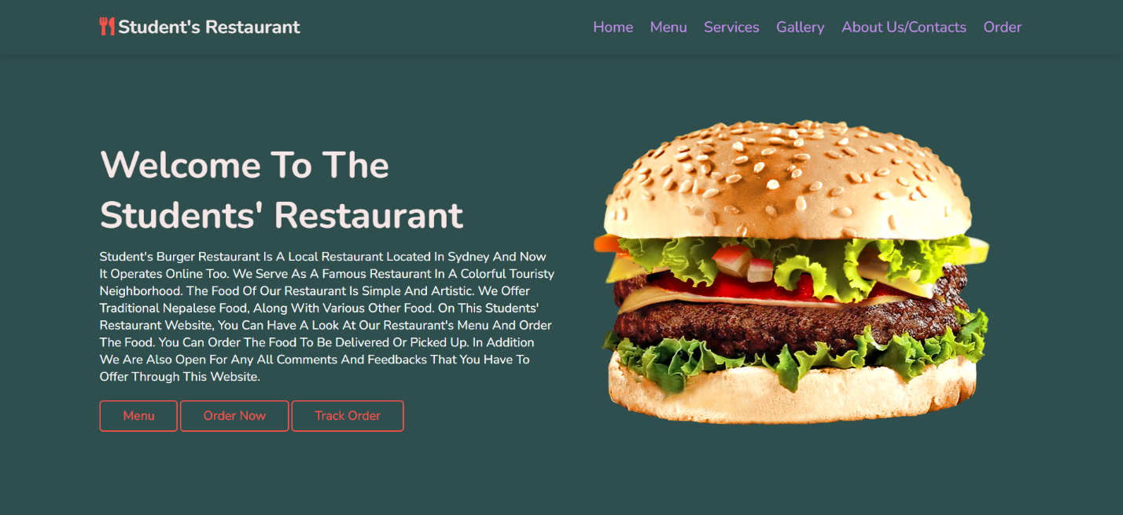

Figure 1 homepage of Students Burger House restaurant

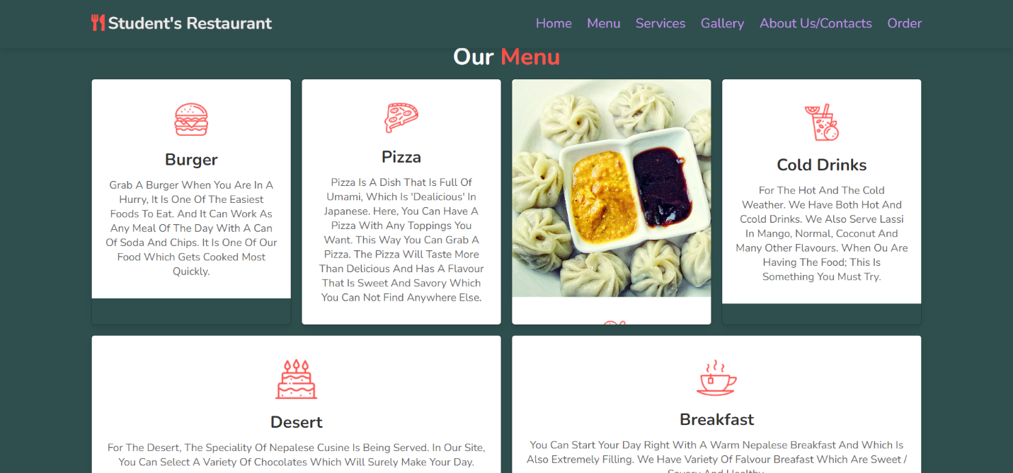

Figure 2 Menu page of Students Burger House restaurant

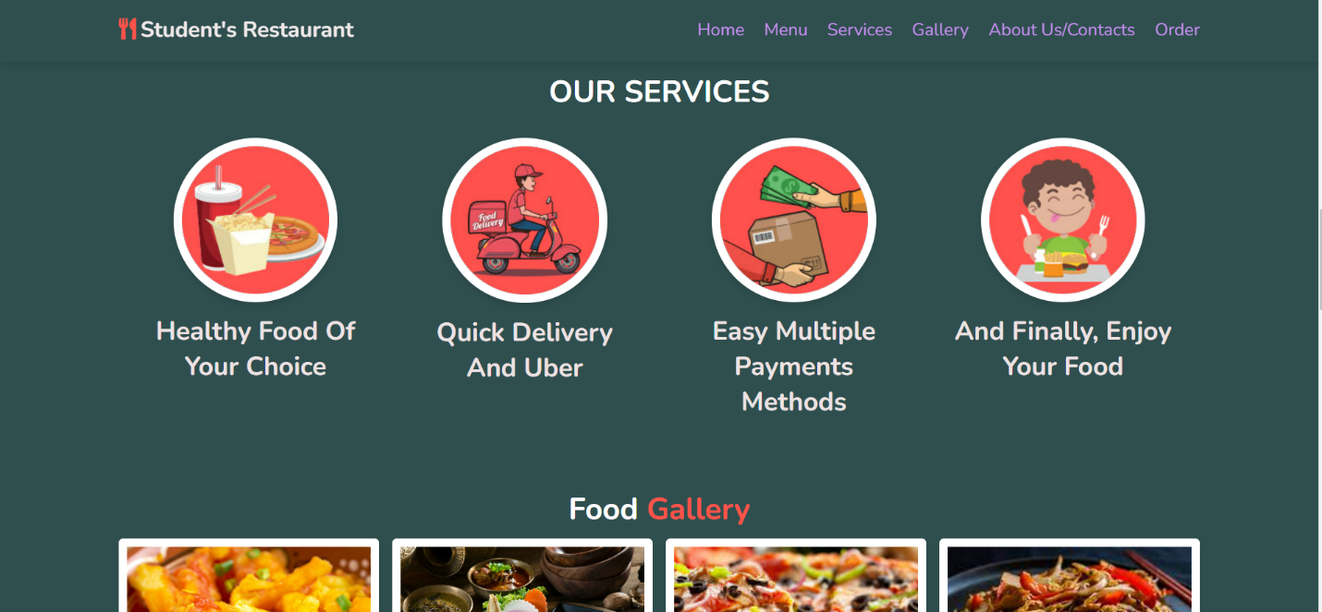

Figure 3 Service page of Students Burger House restaurant

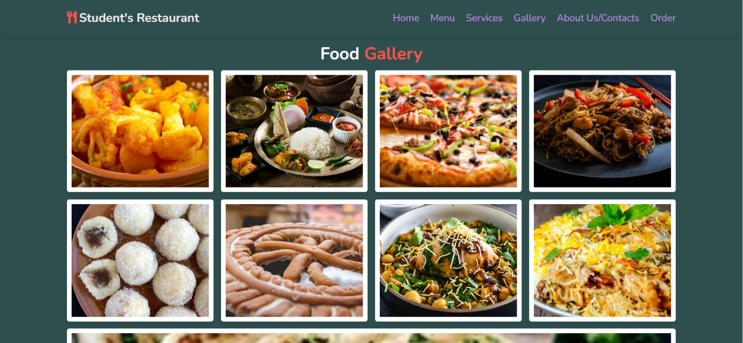

Figure 4 Food gallery of Students Burger House restaurant

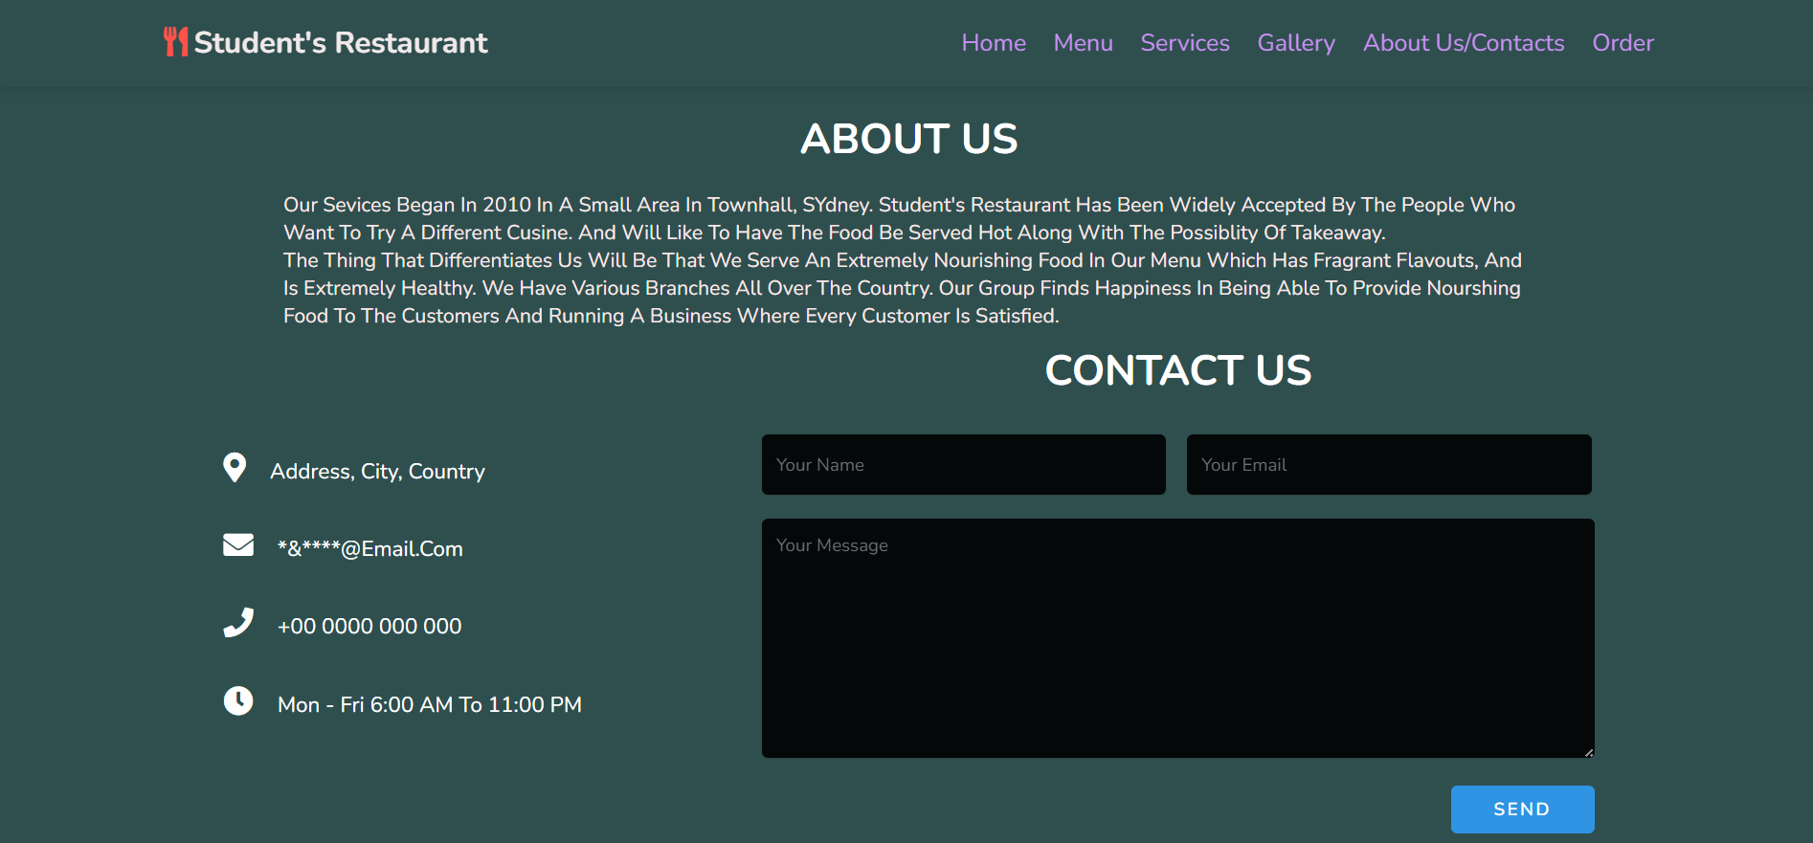

Figure 5 about us and contact us page of Students Burger House restaurant

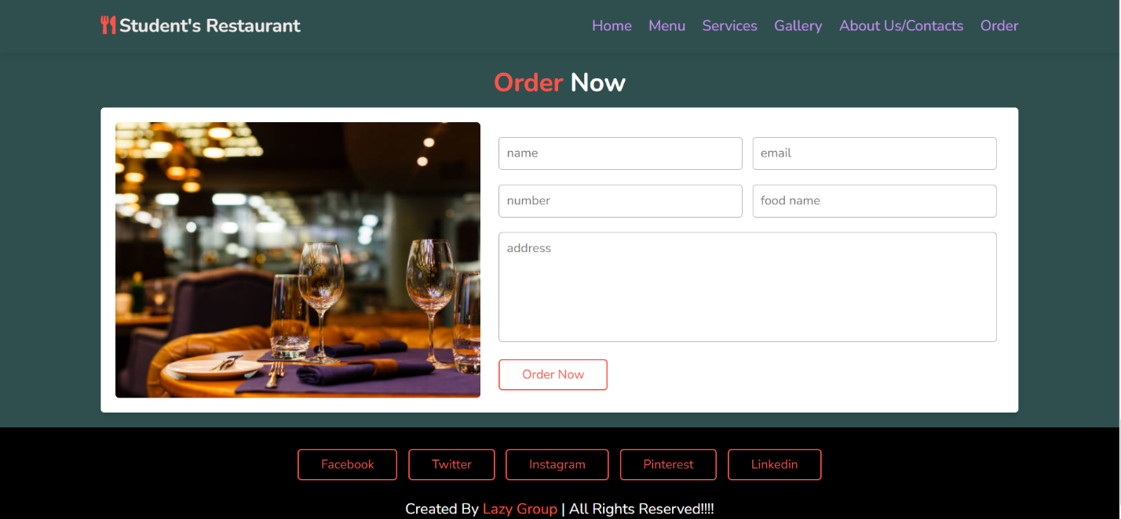

Figure 6 Ordering page of Students Burger House restaurant

# Test Cases:

|  |  |  |  |  |  |
| --- | --- | --- | --- | --- | --- |
| Test case No. | Case description | Testing user input data | Expected results | Result obtained | progress |
| 1. | Enter URL Address in the browser | <HTTP://XYZ.com> restaurant | Should direct you to website home | Homepage is displayed | Test successful |
| 2. | Check all the navigations buttons | All buttons clicked | Should take you to different pages of the website | Redirected to different pages of the website | Test successful |
| 3. | Enter the data in order form leaving the address empty | Name=XYZ  Email: xyz@hotmail.com  Number=0477899383  Food name=” Burger”  Address= empty | Address is not found. | Error message is shown | Test Successful. |
| 4. | Enter the data on contact us page leaving the empty mail address | Name= XYZ  Message=” Food is delicious” | Email address not found | Error message is shown | Test successful. |

All necessary website tests are executed using the provided testing table. To provide some order to the testing process, test tables may be employed. It shows the user's actions, the information they are expected to get by taking the exams, and the information they are given. All possible test cases are laid out in the above table, complete with descriptions of the work to be done, the information the user will submit to the site, and the expected results and outputs. Above, we can see that all of the tests were carried out successfully and access all of the data from the testing table. Initial browser testing of the website's functionality proved successful. The completeness of the site's buttons, including those in the navigation bar, was also thoroughly tested and found to be fully functional. Next, we made sure that the website's alerts functioned as planned, and that it would react appropriately if a user omitted required information during registration.

# Testing and Evaluation

Testing and evaluation are one of the most important phases in the development of the website. This phase is initiated and completed as the second last phase just before the publication. We start this phase after all of the designing and development phases have finished, testing of the website is done to make sure that the user does not have any issues or trouble using the website. In this phase, questions are asked to the user as we allow a selected group of users to try the website and review of the website. Through this, we were able to solve some of the issues in our website and make it better. We included a selected group of old and young group in order to make sure that the website can satisfy both group of users. As the targeted users of our website are all age group of people.

## People to test the website:

|  |  |  |
| --- | --- | --- |
| S.N. | Name | Age |
| 1 | Angelique willsworth | 19 |
| 2 | Nisha Bhetuwal | 21 |
| 3 | Tika Gurung | 50 |
| 4 | Roshan Kapali | 21 |
| 5 | Bhairab Raj Bhetuwal | 60 |

## 

## Questions for Testing and Evaluation:

Angelique Willsworth

1. How was the consistency of the website?

|  |  |  |  |  |
| --- | --- | --- | --- | --- |
| 1 | 2 | 3 | 4 | 5 |

1. How easy was it to surf through the website?

|  |  |  |  |  |
| --- | --- | --- | --- | --- |
| 1 | 2 | 3 | 4 | 5 |

1. How would you rate the interface and design of the website?

|  |  |  |  |  |
| --- | --- | --- | --- | --- |
| 1 | 2 | 3 | 4 | 5 |

1. How is the color contrast?

|  |  |  |  |  |
| --- | --- | --- | --- | --- |
| 1 | 2 | 3 | 4 | 5 |

1. How would you rate your overall experience?

|  |  |  |  |  |
| --- | --- | --- | --- | --- |
| 1 | 2 | 3 | 4 | 5 |

Bhairab Raj Bhetuwal

1. How was the consistency of the website?

|  |  |  |  |  |
| --- | --- | --- | --- | --- |
| 1 | 2 | 3 | 4 | 5 |

1. How easy was it to surf through the website?

|  |  |  |  |  |
| --- | --- | --- | --- | --- |
| 1 | 2 | 3 | 4 | 5 |

1. How would you rate the interface and design of the website?

|  |  |  |  |  |
| --- | --- | --- | --- | --- |
| 1 | 2 | 3 | 4 | 5 |

1. How is the color contrast?

|  |  |  |  |  |
| --- | --- | --- | --- | --- |
| 1 | 2 | 3 | 4 | 5 |

1. How would you rate your overall experience?

|  |  |  |  |  |
| --- | --- | --- | --- | --- |
| 1 | 2 | 3 | 4 | 5 |

## 

## Feedback Graph

# Conclusion:

Student Burger House is a local institution venturing into the internet realm. The website prototype for Student Burger House has been successfully deployed. We should have a complete working model of the Student Burger House by the conclusion of this report. The layouts and pages used in the Student Burger House Report are described in detail. We created a prototype for the Student Burger House website and tested it thoroughly to ensure that it worked correctly. We used a broad array of HTML and CSS components to create the Student Burger House prototype, and we made care to follow all the HCI best practices for online design. The homepage, navigation page, gallery, order page, and so on are all instances of user-friendly sites that we develop. Our whole work went into making our product's user interface and user experience as pleasing as possible. Everyone's creativity contributed to a result that surpassed expectations. People will be lured to the Student Burger House and will visit it more often now that the website has been updated to be both aesthetically attractive and simple to use. Several solutions were examined during the construction of the website to enhance the user interface and user experience. A variety of elements were considered while developing the site. To resolve the problem with Student Burger House, we performed all necessary steps while still achieving the desired outcomes.

# Recommendation:

After reviewing the prototype, test results, and user comments, we are confident in suggesting that the Student Burger house website adopt java script. The usage of just HTML and CSS limits the website's capabilities. JavaScript might have been utilized to increase the functionality of the prototype. Diners may be able to sign up for an account and have access to special bargains in the not-too-distant future by signing in. And from the test and evaluation phase, it can be concluded that some changes still need to be done.

# Member Participation:

|  |  |  |  |  |
| --- | --- | --- | --- | --- |
|  | Family Name | Given Name(s) | Student ID | Participation |
| Student 1 | Regmi | Bimal | 12100195 | 100 % |
| Student 2 | Bhetuwal | Amit | 12100668 | 100 % |
| Student 3 | Kandel | Sujan | 12200901 | 100 % |
| Student 4 | Khadka | Bhoj Bahadur | 12100199 | 100 % |
| Student 5 |  |  |  |  |
|  |  |  |  |  |

# Link to the websites’ HTML and CSS:

The link to the HTML and CSS coding that were used to build the prototype website are as follows:

<https://drive.google.com/drive/folders/1RhsDpX82-bgflnCZQoXn54vCz34Ukyl-?usp=share_link>

# References:

* Test cases sample for website - Google Search. 2023. Test cases sample for website - Google Search. [ONLINE] Available at:  <[https://www.google.com/search?q=Test+cases+sample+for+website&rlz=1C1CHBF_en- gbAU998AU998&oq=Test+cases+sample+for+website&aqs=chrome..69i57j0i22i30l6j0i390l3.9436j0j7&sourceid=chrome&ie=UTF-8](https://www.google.com/search?q=Test+cases+sample+for+website&rlz=1C1CHBF_en-%20gbAU998AU998&oq=Test+cases+sample+for+website&aqs=chrome..69i57j0i22i30l6j0i390l3.9436j0j7&sourceid=chrome&ie=UTF-8) >. [Accessed 14 January 2023].
* HTML Tutorial. 2023. HTML Tutorial. [ONLINE] Available at: <<https://www.w3schools.com/html/>>. [Accessed 16 January 2023].
* CSS: Cascading Style Sheets | MDN. 2023. CSS: Cascading Style Sheets | MDN. [ONLINE] Available at: <<https://developer.mozilla.org/en-US/docs/Web/CSS>> [Accessed 16 January 2023]
* UX courses. 2023. Shneiderman’s Eight Golden Rules Will Help You Design Better Interfaces | IxDF. [ONLINE] Available at: <<https://www.interaction-design.org/literature/article/shneiderman-s-eight-golden-rules-will-help-you-design-better-interfaces>>. [Accessed 16 January 2023].
* Jigsaw Academy. 2023. Prototype Development: A Comprehensive Guide (2021). [ONLINE] Available at: <<https://www.jigsawacademy.com/blogs/product-management/prototype-development/#:~:text=1)%20What%20Is%20Prototype%20Development,and%20meet%20the%20users'%20requirements>.>

[Accessed 16 January 2023].

# Annex

Screenshots of Coding of the prototype:

